**Life on land**

Land use is major contributor to climate change, but it’s also a major contributor to other two great environmental crises, the loss of biodiversity and pollution.

Biodiversity is lost when land areas(forests) are converted for farmers, companies, etc. tree crop, replanting of something else. Massive pollution is done through pesticides, fertilizers that are carried through rivers and groundwater that lead to dead zones.

Worldwide, agriculture is the most significant threat to forests, therefore, to biodiversity.

If we do not change the current system, we are going to follow the trend that you are about to read in this article. However, some solutions that might solve the fundamental problems will be given at the end of the document.

The following chart shows that agriculture occupies more land than all forests around the world in 2017. It is significant amount, especially, considering that not all other land area is liveable.

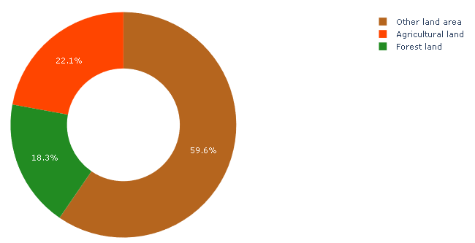However, it is not surprising because agriculture area’s significant growth could be seen over the past years:

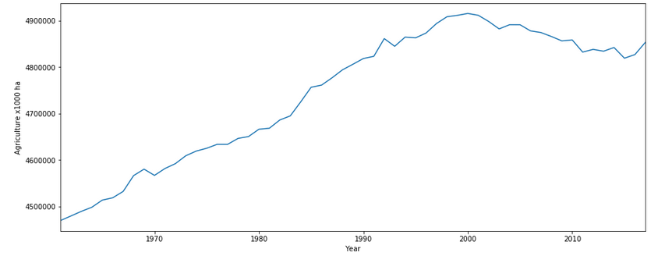

And that is how it looks distributed around the world:

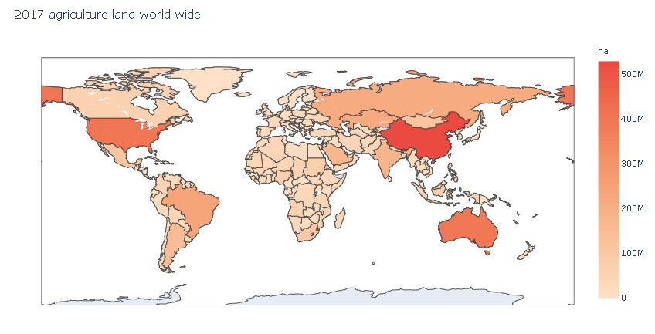

Todays agriculture not only takes up huge amount of land, but it also rapidly pollutes the environment because of the pesticides and fertilizers use.

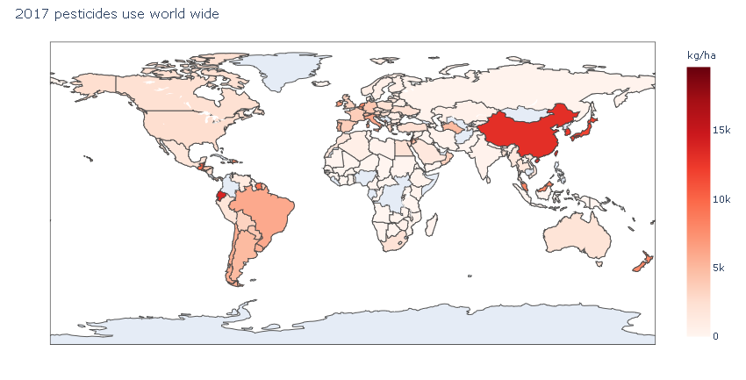

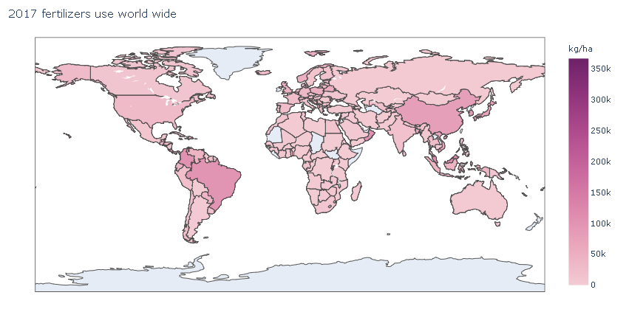

As you could see in these maps, huge amounts of fertilizers and pesticides are used in our agriculture today. Although it helps farmers and companies to increase yields, however, the huge quantities of these chemicals stay in the ground for prolonged time and negatively affect the life there, resulting with a dead zones and polluted ground water.

The question is, what we can do about that? How can we solve agriculture massive land demand and toxic chemicals usage?

In order to address these problems, the following actions can be taken:

Sustainable food systems could replace non-sustainable agriculture solutions so the land use does not have to expand into areas where it should not go, like forests.

Concrete examples for cities and villages are Polydomes that focus on creating food production eco-systems that not only not require fertilizer/pesticide use, but also are more efficient for the same amount of land.

In addition, these systems could even be placed on the roofs of the city buildings.

While some cities would be able to mostly supply for themselves the demand for outside agriculture would diminish.

It will take some time, but this new type of agriculture could escalate quickly simply because it is advantageous for every party involved.

Therefore, the trend of using fertilizers/pesticides would collapse resulting in a great life on land benefits. Furthermore, the land earlier used for agriculture could be planted with forests.